**ELEGANT GLOBAL PERFORMANCE ANALYSIS REPORT FOR THE YEAR 2019**

**Introduction**

The Elegant Global Performance analysis for the year 2019 . The analysis was conducted to support the identification of key trends and patterns which was achieved from a deep dive into different salespersons, regions, customers and cities to provide insights for data-driven decision making. The findings from this analysis will help the business evaluate and improve sales performance, refine strategies for increasing market share and competitive advantages, all these are with improving revenue as the overall goal.

**Objectives of the Project**

The main objectives of the project are:

* Determine the contribution of individual salesperson performance to highlight top performers to align strategies for improved performance.
* Review customers contributions to the overall sales, product preference and regional sales metrics
* Identify existing areas of strengths and weaknesses while adopting strategies to optimize those performance
* Analyze customer purchasing behavior, focusing on transaction values and preferred product categories.
* Derived insights on the performance of different product categories to the business total revenue.

The business can leverage the insights from this analysis to implement data-driven business decisions to improve sales performance and operational strategies. The derived insights would help address these concerns for the business;

* The regional contribution to overall sales and revenue.
* The highest selling product category and factors contributing to high sales.
* Contribution from salesperson, identifying the highest performer and ways to replicate the skill of this person across the whole business.
* How do the different cities contribute to the overall sales? And ways of optimizing their contributions.

**Key Datasets and Methodologies**

The project is based on the analysis of sales data for Elegant Global for the year 2019. The dataset includes information on sales, customers, products, shipping cities, operational cities and regions. Other information identify in the dataset are:

* **Salespersons Data** – Assessing the contribution of this individuals to the overall revenue generated
* **Sales data**– Detailing revenue, sales figures and transactions
* **Customer information** – Helping to spotlight the customers including the top performing customer.
* **Product Category -wise revenue contribution** – Identifying the star product categories and their contribution to total sales.
* **Regional Sales Distribution** – Assessing regional contributions to sales

**Methodologies**

The analysis was conducted using Microsoft Excel and applying some of it functions:

* **Trends analysis** – sales trend analysis using a line chart to visualize the data.
* **Pie & Bar Charts** – Visual presentations of Sales data (Salespersons), customer influence, regional and cities contribution
* **Pivot Tables & Charts** – Support data grouping and visualization

**Dataset Description and Preprocessing**

The dataset, sourced from an internal transaction system, was verified to be structured and free from inaccuracy and inconsistency, the data quality was good for the analysis. The data was observed for consistency in numerical values. A pre-processing stage was carried out, and the data classified into two categories and variables:

* **Independent Variables** – Customers details, Order details, salesperson, regions, product name and category, operational cities, shipper name.
* **Dependent Variables** – Sales values, quantities, shipping cost, unit price,

A trend analysis for a comparative study was not possible because the dataset was for just the year 2019. Projection of the result of this single year trend analysis might not completely represent future sales trends for this business

**In-Depth Analysis & Insights**

1. **Top Salespersons Performance.**

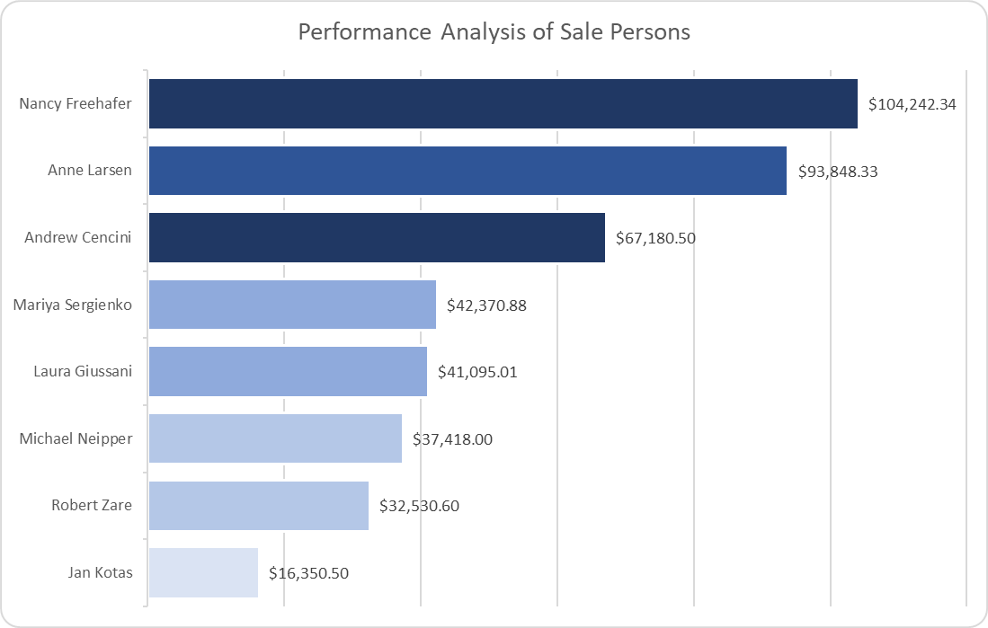

* + Nancy Freehafer led in sales, generating $104,242.34.
  + Jan Kotas has the lowest sale values for all 8 salesperson analyzed

1. **Regional Performance**

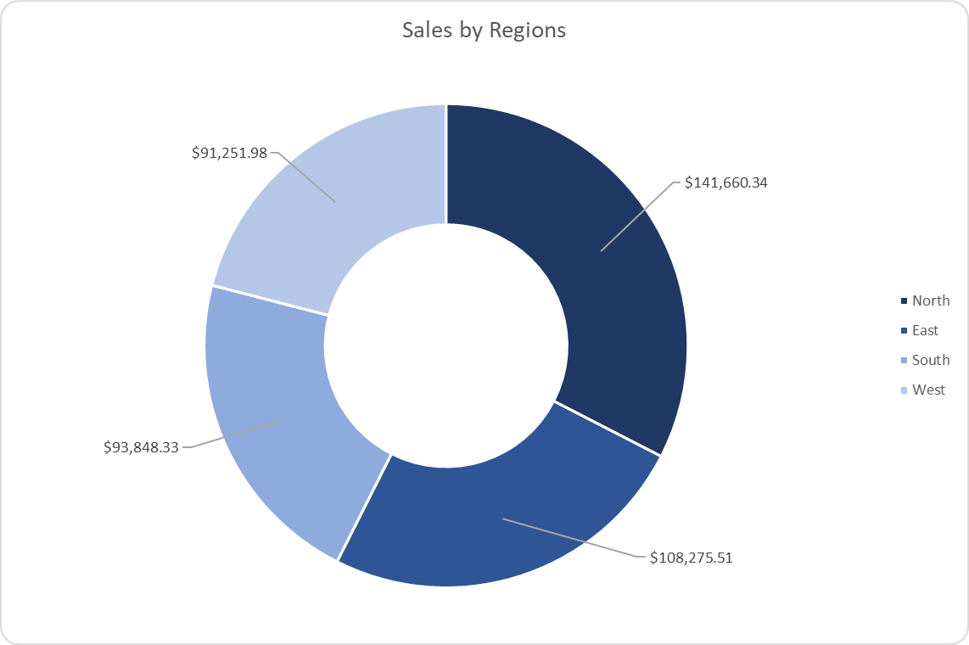

* + The North region yielded the highest revenue ($141,660.34)
  + The west region had the lowest revenue, low performance targets and a need for holistics support of this region.

1. **Product Category patterns:**

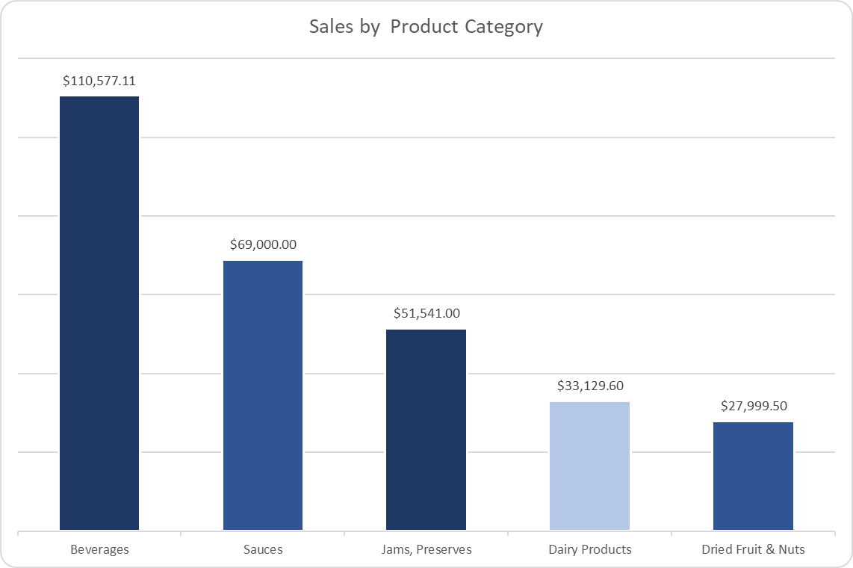

* + Beverages were the highest revenue-generating category, contributing $110,577.11.
  + Sauces and Jams & Preserves followed, while Dried Fruit and Nuts had the lowest sale

1. **Customer Performance**

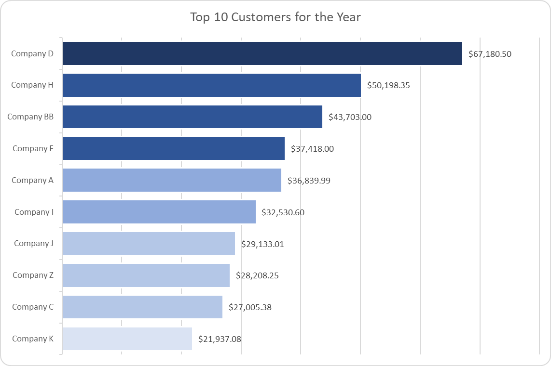

* + Company D account for the highest sales and the top performing customer
  + Company K was the lowest performer customer in the top 10 customers analyzed.

1. **Sales Trends:**

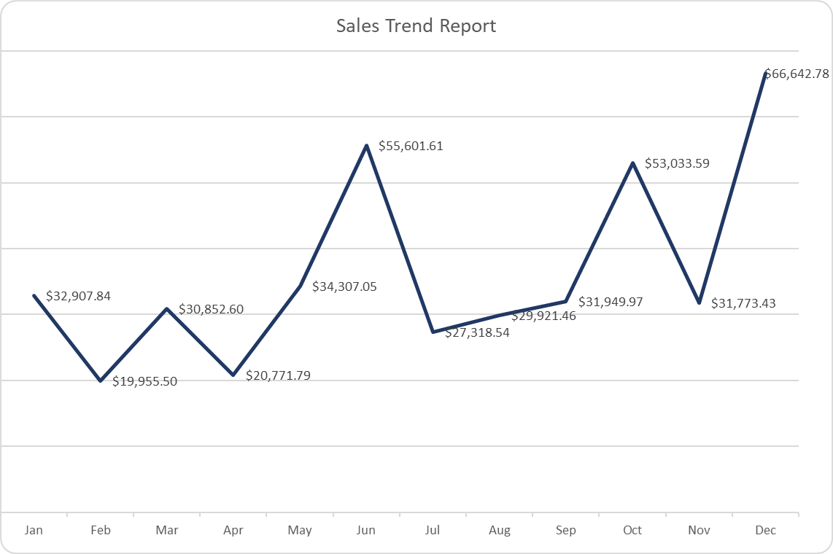

* + December showed the month with the highest revenue ( peak revenue)
  + The sales trends show great fluctuation in all the months in 2019.
  + February and April are denoted as the months with the lowest revenue, this shows a potential for these months to support promotional and sales targeted strategies.

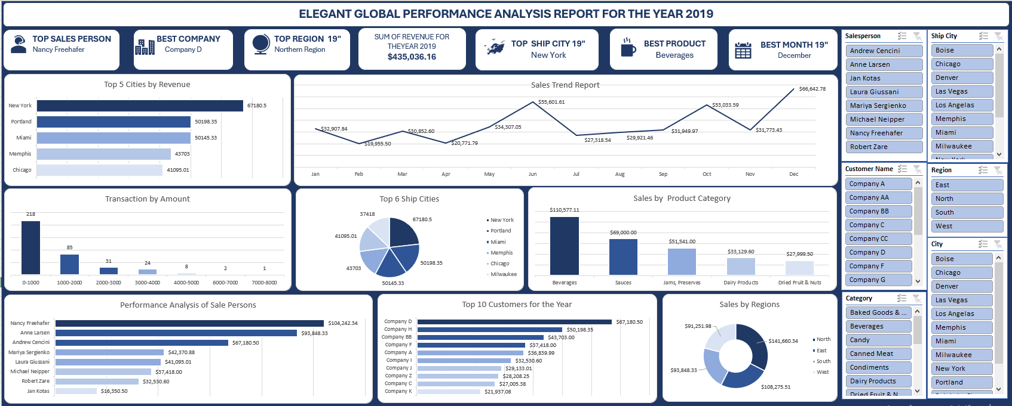

**Strategic Recommendations**

Based on the findings, the following strategies are recommended:

1. **Replicate High-Performing Sales Strategies** – Analyzing Nancy Freehafer’s sales approach and implementing similar techniques across the team to boost performance.
2. **Expand Strong Regional Strategies** – Adapting the North region’s successful sales and marketing tactics to underperforming areas.
3. **Optimize Product Pricing & Promotions** – Leveraging bulk purchase discounts and upselling strategies to increase revenue per transaction.
4. **Enhance Inventory Management** – Ensuring consistent stock availability for high-demand products, particularly beverages.
5. **Improve Logistics & Order Processing** – Enhancing efficiency in high-volume shipment cities like New York and Portland.
6. **Strengthen Customer Loyalty Initiatives** – Offering incentives to repeat buyers and top clients such as Company D.
7. **Invest in Sales Training** – Providing targeted coaching to underperforming sales representatives like Jan Kotas to enhance their efficiency.
8. **Leverage Digital Sales Channels** – Expanding online marketing efforts to capitalize on higher conversion rates in digital platforms.
9. **Diversify Client Base** – Reducing reliance on a few key customers by expanding lead generation and strategic partnerships.
10. **Seasonal Promotions** – Implementing holiday-centric marketing campaigns to maximize revenue during peak months.

**Conclusion**

It is clear that this business can use all the trends and insights to achieve data-driven decision making to optimize sales, improve performance of key individuals and obtain a market share that encourages better competitive advantage. For the industry, this analysis highlights the importance of diversifying market reach, training underperforming salespeople, and leveraging seasonal trends to drive sales growth.